

**Carrier 2.0HP A5CKY 20E/A5LCY 20C**

**Rs. 219,900/-**

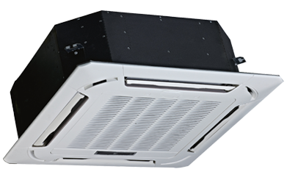

**Product Features**

* dry function
* wide voltage
* active PFC technology
* more luxury to your living room
* anti dust

**Specification**

**Type** Ceiling Cassette AC

**Cooling (Btu/h)** 49000

**Voltage (V)** 220-240

**Power Input (W)** 6600

**EER (Btu/W-h-W/W)** 6.3-2.8